**Analysing motion graphs**

1. Look at the displacement-time graph below.

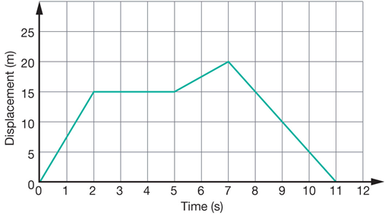

* 1. Describe the motion of the object in the graph.
  2. What distance has the object travelled in total?
  3. What is the object’s final displacement?

1. Describe the changes in motion for the objects in the graphs below. (Constant velocity, accelerating, decelerating etc.)

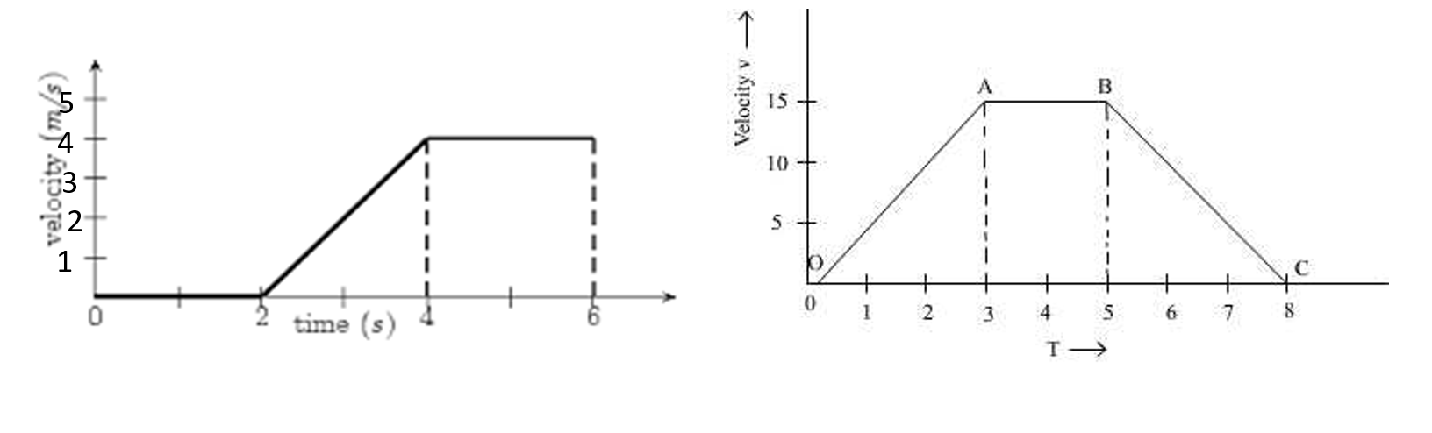

1. Find the displacement of the objects in the above velocity-time graphs.

4. A remote control car moves along a straight line. Its displacement from the starting point is shown as a function of time.

1. Determine the displacement of the object at 5.00 s?
2. Which section or sections of the graph represents a constant velocity of 3.00 ms-1? You must include calculations to justify your answer.
3. Which section of the graph represents the object at rest?

1. Determine the velocity for section C-D?
2. Determine the time elapsed before the car returned to its starting point?

f. Sketch a velocity/time graph of the journey.

5) The graph below shows the motion of a remote control car relative to the person controlling the car. The time starts as the car passes the person.

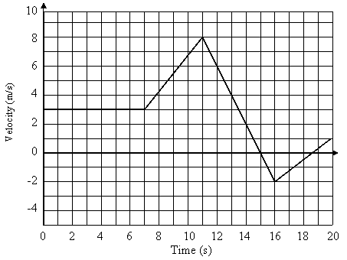

1. Describe the motion between 4th and 10th seconds.

(3 marks)

1. How far does the car travel during the first 11 seconds?

(3 marks)

1. Compare the motion of the car at the 9th second to the motion of the car at the 12th second.

(3 marks)

d) Compare the motion of the car at the 9th second to the motion of the car at the 18th second.

(3 marks)

e) What is the maximum distance the car gets from the person?

f) What is the rate of acceleration from the 16th second to the 20th?